A
Mini Project-II Synopsis
on
College Placement Drive Management System

by
GROUP DETAILS

Name of Student | Roll No.
Shreyash Sanjay Mandave | 152
Vishwajit Ananda Disale | 164
Om Anil Dangare | 176
Om Satappa Nakate | 177
for the degree of
Bachelor of Technology
in
Computer Science and Engineering
Under the Guidance of
Prof. S. D. Mule
Assistant Professor



SWVSM’s

Tatyasaheb Kore Institute of Engineering and Technology, Warananagar (An Autonomous Institute)
Department of Computer Science & Engineering
Academic Year 2025-26

Mini Project-II Synopsis
Mini Project-II Title :- College Placement Drive Management System
- Problem Statement:
This project aims to develop a College Placement Drive Management System that automates the placement process and improves communication between students, placement coordinators, and companies.

- Objectives:
- To develop a system that manages student and company placement information efficiently.
- To simplify the process of organizing placement drives in colleges.
- To maintain records of students eligible for different companies.
- To provide quick access to placement details for placement coordinators

- Introduction:
The College Placement Drive Management System is a web-based application designed to manage and organize placement activities in colleges. It helps the placement cell maintain records of students, companies, and placement drives in a structured manner.
In traditional systems, placement data is often stored manually or in scattered files, which makes management difficult. This system provides a centralized platform where placement coordinators can manage student details, company requirements, and placement schedules efficiently. The system improves accuracy, reduces paperwork, and saves time

- Motivation:
- The placement process in many colleges is still managed manually, which can cause delays and errors.
- It allows placement coordinators to easily manage student records and company information.
- In the real world, many colleges and universities require digital systems to efficiently manage placement activities.

- Existing System:
In the existing system, placement information is often maintained manually using registers, spreadsheets, or basic documents. Placement coordinators collect student information and share company details through notice boards or messages. Students must check updates manually, which is inefficient and time-consuming.

Limitations of Existing System:
- Time-consuming manual data management.
- High chances of data duplication or errors.
- Difficult to track eligible students for each company.
- Lack of centralized database.
- Poor communication between placement cell and students.

- Scope of the Project :
The scope of the College Placement Drive Management System includes managing student details, company information, and placement drives within a college.

Included Features:
- Add and manage student information.
- Add company details and eligibility criteria.
- Manage placement drive schedules.
- View placement records.

Excluded Features:
- Student login module (if not included in your project).
- Online interview process.

Limitations:
- System is designed mainly for college placement cell use.
- Requires internet and system access to operate.

- Methodology/Approach:
The project will be developed using a web-based approach, where the placement coordinator can manage placement information through an interface. The system will store and process data in a structured database.

A. Tools and Technologies
- HTML
- CSS
- JavaScript
- MySQL Database
- Web Browser

B. System Design: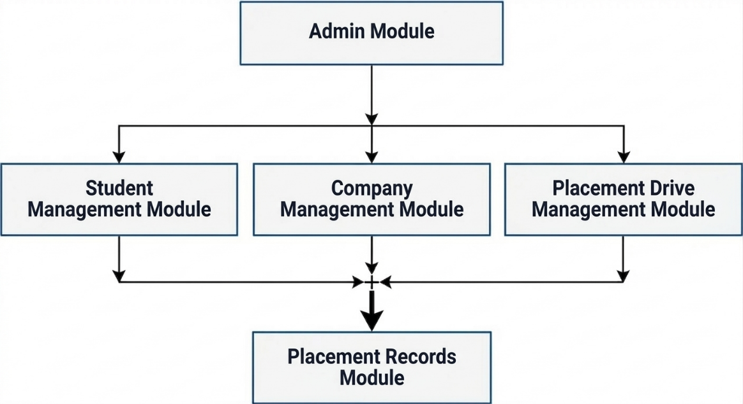
Fig. 1 Block Diagram of College Placement Drive Management System

C. Algorithms:
Database management using CRUD operations (Create, Read, Update, Delete). Data validation for storing student and company details.

D. Modules:
  - Admin Module
  - Student Management Module
  - Company Management Module
  - Placement Drive Management Module
  - Reports / Placement Records Module:

E. Software Requirements:
  - Operating System: Above Windows 10
  - Web Browser: Google Chrome / Edge
  - Programming Language: HTML, CSS, JavaScript
  - Database: MySQL
  - IDE: VS Code

F. Hardware Requirements:
- Processor: Intel i3 or higher
- RAM: Minimum 4 GB
- Hard Disk: 500 GB
- Internet Connection

References :-
i. Journal / Conference Papers
- R. Kumar and S. Gupta, “Online Placement Management System for Colleges,” International Journal of Computer Applications (IJCA), Vol. 182, No. 15, pp. 10–15, 2018.
ii. Web References
- https://www.tutorialspoint.com⁠ (Web Development Tutorials)
- https://www.mysql.com⁠ (Database Documentation)

Prof. S. D. Mule Prof. V. N. Patil Dr. R. B. Patil
Project Guide MP-II, Coordinator HoD, CSE

